**INHA UNIVERSITY TASHKENT**

**DEPARTMENT OF CSE & ICE**

**SPRING SEMESTER 2020**

**SOC 2110 – INTERNET PROGRAMMING**

**Submitted by**

**Student Name Student ID Section**

Alimov Bekhzod U1810201 002

Numonov Akromjon U1810239 001

Olimov Odilbek U1810235 001

Eshmurodov Alisher U1810178 001

Botirov Ulugbek U1810275 001

Jurabekov Komronbek U1810220 001





**Team: Positive Hackers**

**Team motto: “Think Simple and stay positive”**

**Github:** <https://github.com/iuthub/ip-group-project-positive-hackers.git>

**Website link:** [**http://theblogge.beget.tech/**](http://theblogge.beget.tech/)

**Or http://positive-hackers.xyz/**

**Business scenario: Simple Blog Website**

**Features:** Simple Blogging website with simple admin system control system. There are two versions. First is user based system and the second is Admin system.

**USER-BASED-SYSTEM**

**It has three main features in a user based system.**

1. Home- Home page collects all data from its database. At the top, There is a slider which actually animates orderly. After that, you can actually see all posts and its categories and tags. At the bottom, there is a footer section which actually shows team members who contributed mostly in front-end section.

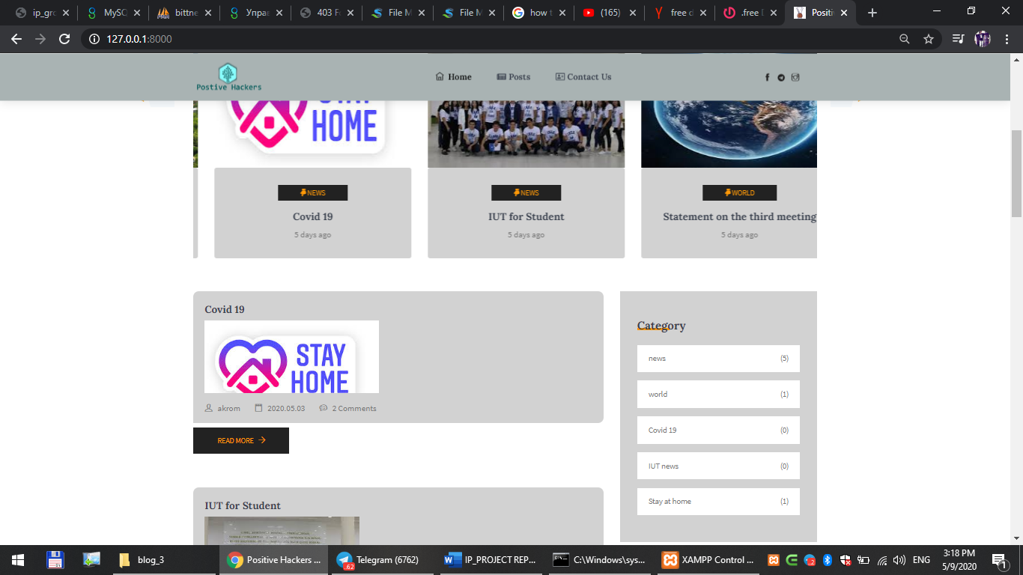

1. Post-Posting page gets all posts in one place. The users can click and then read a particular post in singled page.

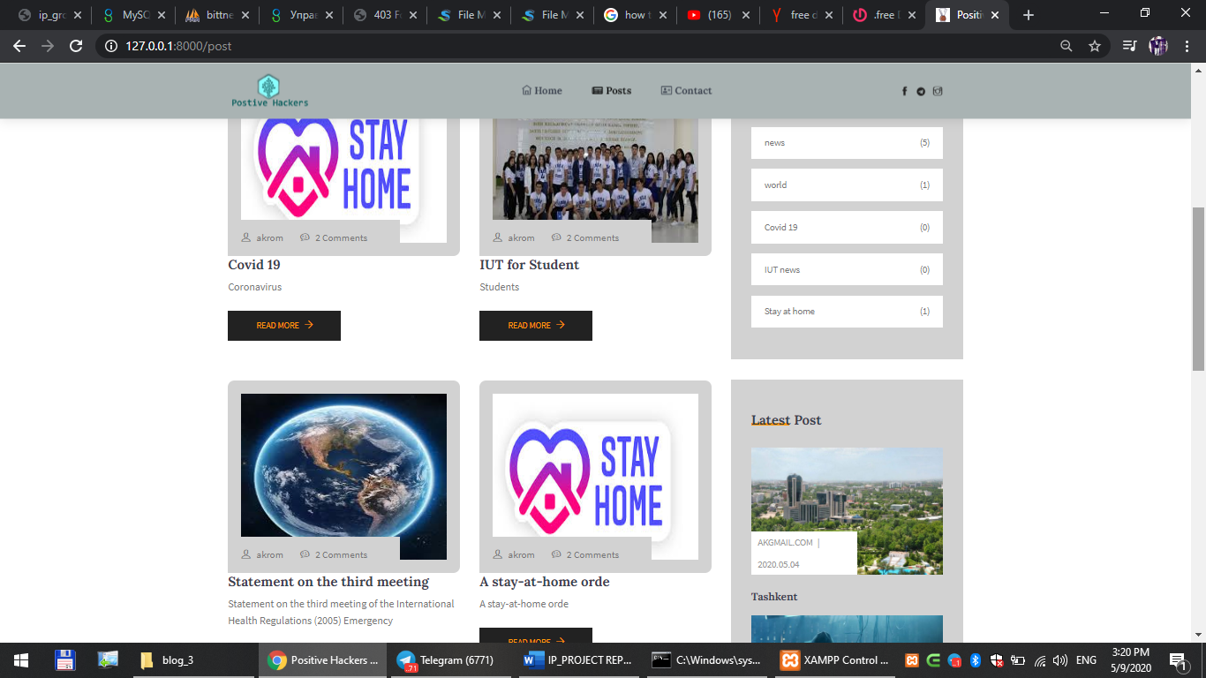

1. Contact- Contact page is contact page where users can get information about us. There are emails and phone numbers and organization address.

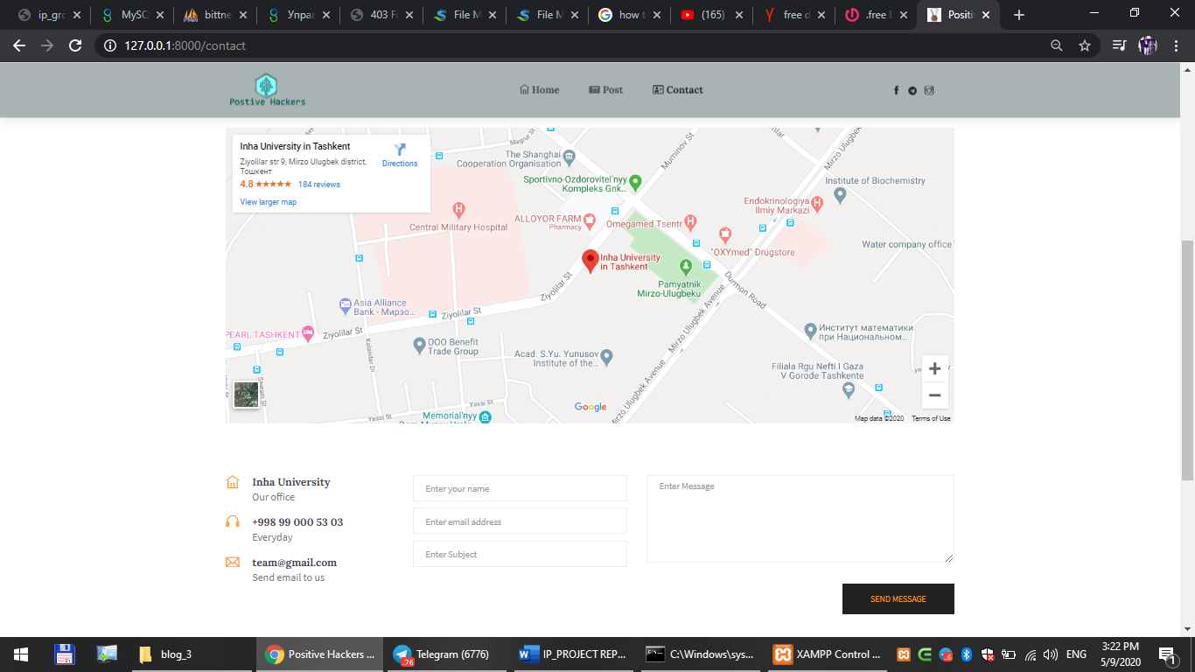’

**ADMIN-BASED-SYSTEM**

Admin control system- it controls following things: **users, posts, tags, categories, trashed posts.** Admin system is accessed in following steps.

[site domain]/admin

For example: <http://127.0.0.1:8000/admin>

1. Users page-> this page is only accessed via Admin login and password. It has two options. One can be writer or Admin.
2. Post-> This page is the page where writes and admins can actually create different post or articles along with its cover picture.
3. Tags-> this is page is for tags
4. Categories-> that is for Categories

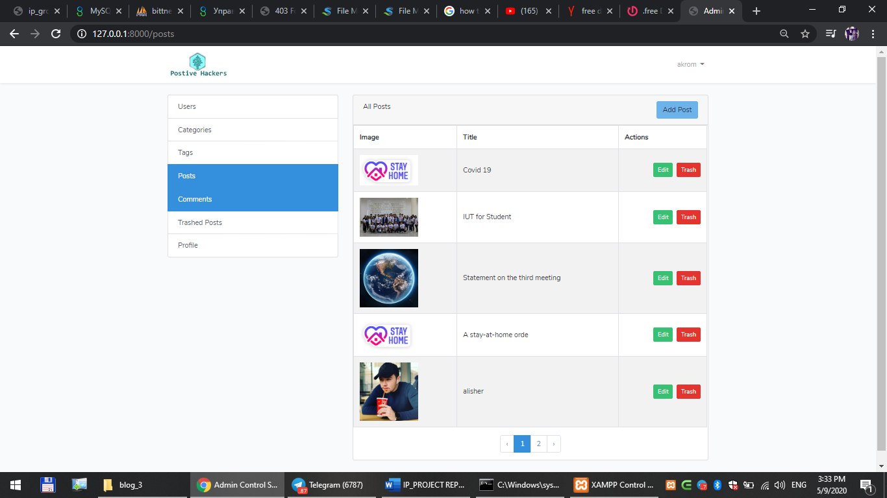

**Team members contribution:**

**Due to internet issues of some team members, we could use mostly Telegram Chatting app rather than using github to keep up work. Finally, We uploaded the project to github.**

**Akromjon Numonov** – he is the team leader and maintained both front-end and back-end work in order. He was mainly doing the controllers and database.

**Alimov Bekzod-** he was responsible for the routes and controllers too. His biggest contribution was in Admin Control System section which did himself.

**Eshmurodov Alisher-** He was a designer. He first created the design for web site in Photoshop. After that, He started writing down the codes for front-end section for user-based-system. His the biggest contribution was home page.

**Botirov Ulugbek-** He was also front-end developer and he helped the group with his hard work in posts page and contact page. And his biggest help was in post and contact pages equally.

**Olimov Odilbek-** He was coding in admin based control system. And also he was one who came with logo and motto for the group. He also helped to create Controllers. His huge work is in Admin control system front.

**Jurabekov Komron**- He was working both user page and admin page front section. He also helped us with his back-end skills in Post Controllers. His biggest help was basically front-end.